IMPERIAL COLLEGE LONDON

BSc and MSci DEGREES – JANUARY 2014, for Internal Students of the Imperial College of Science, Technology and Medicine

This paper is also taken for the relevant examination for the Associateship

CHEMISTRY FOUNDATION PAPER ONE

Monday 13th January 2014, 14:00-16:15

USE A SEPARATE ANSWER BOOK FOR EACH QUESTION. WRITE YOUR CANDIDATE NUMBER ON EACH ANSWER BOOK.

Found/0114 Turn Over

1.F2 – Atomic Structure

This question is worth 25 marks.

Answer parts a) and b) and EITHER part c) OR part d) of this question.

- Answer ALL parts of this question.

- Which sub-shells can occur in the following primary quantum levels, and what is the relative energetic order of the sub-shells within each primary quantum level:

n = 2; n = 3; n = 4

(3 marks)

- Calculate the total energies, in eV, of the first three electron shells of the hydrogen atom (ionisation energy of hydrogen, E_{i,H} = 1312.8 kJ mol⁻¹)

(5 marks)

- Use Slater’s rules to calculate values of Z_{eff} for (1) a 4s electron and (2) a 3d electron in a copper atom, and thereby predict the ground state configuration for the Cu⁺ ion.

(5 marks)

- Decide whether the following electronic configurations are correct, giving reasons for your answers.

- Ge = 1s²2s²2p⁶3s²3p⁶4s²3d¹⁰4p²

(2 marks)

- Sc = 1s²2s²2p⁶3s²3p⁶4s¹3d²

(2 marks)

- Gd = 1s²2s²2p⁶3s²3p⁶4s²3d¹⁰4p⁶5s²4d¹⁰5p⁶4f⁸6s²

(2 marks)

- Following excitation, an electron in the hydrogen 4p orbital decays to the 2s orbital. Calculate the energy change for this transition, and explain whether the energy change is positive or negative.

(6 marks)

QUESTION CONTINUED OVERLEAF

- Answer ALL parts of this question.

- Write equations that represent the first and second electron affinities of an oxygen atom.
(2 marks)

- The first electron affinity of an oxygen atom is -141 kJ mol⁻¹ and the second is +798 kJ mol⁻¹. Suggest why the first value is exothermic and the second is endothermic.
(2 marks)

- Magnesium burns brightly in oxygen to give magnesium oxide, which contains the ions Mg²⁺ and O²⁻. The formation of both these ions from their elements is strongly endothermic. Why does magnesium combine with oxygen?
(2 marks)

1.F3 – Aromatic Chemistry
NB. ‘Half a question’ (out of 12.5 marks).
Answer part a) and EITHER part b) OR part c) of this question.
- Answer ALL parts of this question.
Explain the following observations and comment on the significance of your explanations to our understanding of aromaticity.

- Alkenes decolourise bromine water, benzene does not.
(2 marks)
- The heats of hydrogenation of cyclohexene, 1,3-cyclohexadiene, and benzene are -120 kJ mol⁻¹, -232 kJ mol⁻¹ and -208 kJ mol⁻¹ respectively.
(2 marks)
- The hydrogens of benzenoid rings are found to resonate at high chemical shift values in NMR spectra (i.e., they are deshielded).
(2 marks)

- Draw the expected major product of the following reaction, draw a mechanism and briefly justify the regiochemical outcome.

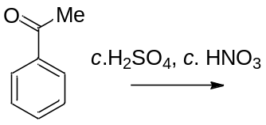
(6.5 marks)

- Draw the expected major product of the following reaction, draw a mechanism and briefly justify the regiochemical outcome.
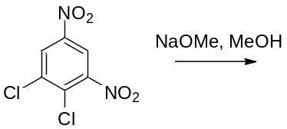
(6.5 marks)

1.F4 – Chemical Equilibria

This question is worth 25 marks.

Answer part a) and EITHER part b) OR part c) of this question.

- Answer ALL parts of this question.

- Describe what is meant by open system, closed system and isolated system.
(2 marks)
- Describe the differences and similarity between Gibbs free energy and Helmholtz free energy.
(3 marks)
- Jet engines can be powered using n-dodecane (C₁₂H₂₆) which burns according to the following chemical reaction:
2 C₁₂H₂₆ + 37 O₂ → 24 CO₂ + 26 H₂O
Using the data given below, calculate the standard enthalpy of combustion of 10 dm³ of n-dodecane.
Δ_{f}H^{ө} [C₁₂H₂₆] = -351 kJ mol⁻¹
Δ_{f}H^{ө} [CO₂] = -394 kJ mol⁻¹
Δ_{f}H^{ө} [H₂O] = -286 kJ mol⁻¹
Density of C₁₂H₂₆ = 0.78 kg dm⁻³
(5 marks)

- Assuming isobaric conditions and that all of the heat energy evolved during the combustion is transferred to the jet engine, calculate the temperature change of the engine. The engine has a mass of 2500 kg and a heat capacity (C_{P}) of 0.47 kJ K⁻¹ kg⁻¹.
(3 marks)
- Answer BOTH parts of this question.

- Describe what is meant by a reversible process?
(2 marks)

QUESTION CONTINUED OVERLEAF

- In living organisms, the sugars sucrose, glucose and fructose exist in equilibrium as described by the chemical equation below.

Sucrose (aq) + H₂O (l) ⇌ Glucose (aq) + Fructose (aq)

Using the following table of temperature and equilibrium constant data for the hydrolysis of sucrose, find ΔHº and ΔSº and ΔGº for the reaction. State all assumptions made.

T / K | K
278.15 | 68500
288.15 | 54700
298.15 | 44400
308.15 | 36500
318.15 | 30400
328.15 | 25600
(10 marks)

- Answer ALL parts of this question.

A research submarine contains equipment that is powered by a high performance lithium iodine battery.
The battery is made by coupling the following two electrochemical half-cell reactions (both shown as reductions):

Li⁺ (aq) + e¯ ⇌ Li (s) E^{ө} = -3.03 V
I₃¯ (aq) + 2e¯ ⇌ 3I¯ (aq) E^{ө} = 0.536 V

The I₃¯ triiodide species is produced by the following reaction between iodine and iodide:

I₂ (aq) + I¯ (aq) ⇌ I₃¯ (aq) Equilibrium constant (K) = 730

The submarine battery contains Li metal with 1 M LiCl and I₃¯ is produced by the reaction between 0.1 M I₂ and 1 M KI.

QUESTION CONTINUED OVERLEAF

- Write down an expression for the equilibrium constant for the reaction between iodine (I₂) and iodide (I¯).
(2 marks)
- What is the concentration of I₃¯ in the battery assuming that the concentration of I¯ is sufficient to make changes in its concentration negligible?
(3 marks)
- Calculate the potential of the half-cell produced by the reaction between 0.1 M I₂ and 1 M KI at a temperature of 298 K. State all assumptions.
(3 marks)
- The submarine equipment requires at least 2.8 V to operate. Assume the temperature of the ocean varies according to the following equation (for temperature in K and depth in m):
Temperature = 298 – 0.02 × depth
Will the equipment still operate at the submarine’s maximum working depth of 1000 m (assume the output of the battery is independent of pressure)? Explain your answer.
(4 marks)

1.F5 – Stereochemistry

NB. ‘Half a question’ (out of 12.5 marks).

This is a multiple choice question. A correct answer will be given full marks. An incorrect answer will be given zero. Please only mark one answer per question.

Answer ALL of the following:

1) Based on diagram X, which is the correct Newman projection?
(2 marks)

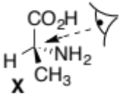
A) 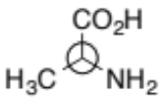

B) 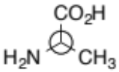

C) 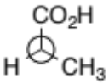

D) 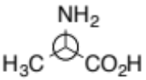

2) For which one of the molecules below has the correct order of priority been assigned?
(2 marks)

A) 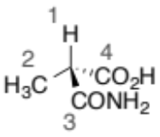

B) 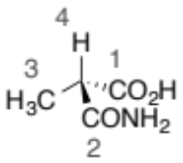
QUESTION CONTINUED OVERLEAF
C) 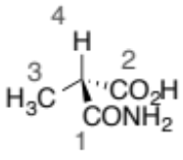

D) 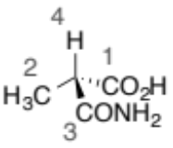

3) What is the correct stereochemical assignment of the chiral molecule below?
(3.5 marks)

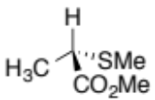

A) R

B) S

C) achiral

D) meso

4) Which of the following molecules is chiral and dissymmetric?
(2.5 marks)

A) 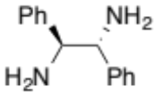

B) 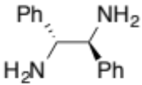

C) 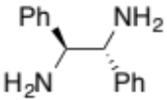

D) 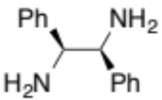

QUESTION CONTINUED OVERLEAF

5) Which of the following molecules is meso?
(2.5 marks)

A) 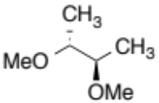

B) 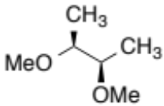

C) 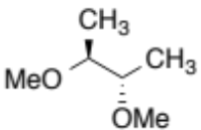

D) 